HongKong Metropolitan University

COMP 8090SEF
Data Structures And Algorithms

Course Project Report

Submission date: 9 April 2026

I declare that:
(i) I have read and checked that all parts of the project (including proposal, code programs, and reports), they are contributed by me, here submitted is original except for source material explicitly acknowledged;
(ii) the project, in parts or in whole, has not been submitted for more than one purpose without declaration;
(iii) I am aware of the University's policy and regulations on honesty in academic work and understand the possible consequence when breaching such policy and regulations;
(iv) I confirm that I have declared in the report about the usage of AI and other generative models, including but not limited to ChatGPT, LLaMA, Gemini, Mistral, and Stable Diffusion, and complied with the instructions provided by HKMU; and
(v) I am aware that I should be held responsible and liable to disciplinary actions, irrespective of whether I have signed the declaration and whether I have contributed, directly or indirectly, to the problematic contents.
I confirm that I have read through and understood the project requirements. I understand that failure to comply with the project requirements will result in score deduction.

NAME | SID
HE Xue | 13927408

Course Project Report
SmartPET - a Pet Shop Management System

- Introduction
I developed SmartPET, an OOP-based pet shop management system that designed to help pet store owners manage their business operations efficiently as my Task 1 of the COMP8090SEF course project. The system provides three core functions: managing pet inventory, tracking customers, and processing sales. It demonstrate Object-Oriented Programming concepts in a practical, real-world scenario.

  - Core Functions
Function | Description
Managing Pet Inventory | Add, view, and manage pets with details including name, age, price, type etc.
Tracking Customers | Maintain customer records with contact information and purchase history

The repository link is:

The video link is:

Task1: OOP-based application development (50%)
OOP= Object-oriented Programming
用到课上说的所有关于OOP的概念，用Python去开发一个程序
This project focuses on real-life problem solving with the concept of Object-Oriented Programming (OOP).
To develop a Python application with multiple modules/files (no
less than 3 modules) using ALL OOP concepts introduced in the
course. OOP concepts not covered in the course are also welcome.
Task 1：基于OOP的应用开发（50%）
开发一个真实的Python应用系统，解决现实生活问题，必须体现课程中介绍的所有OOP概念（封装、继承、多态、抽象类等），并使用模块化编程（至少3个Python文件/模块）。
such as an inventory system, a library management system, calendar and flight scheduling system, etc.
A decent graphical user interface (GUI) may slightly increase your score, but it is not mandatory for you to have a GUI for your project, as you can present the interface with Python print() function.

Notice: You may extend the project you have done on other courses from the previous semesters with modular programming and data structure added. However, you must
(a) declare in the final report that the topic of the project is based on the work (of which group member(s) or of the whole group) from that course e.g. COMP1080SEF, and
(b) demonstrate in the final report that your submission for this course contains significant changes and improvements (no less than 60% new content added in) compared with the work submitted for the previous courses.

Problem definition 10%
1. Clearly state and formulate the real-life problem to be addressed
2. Sufficiently survey how this problem is solved in real life
3. State the data structure to be used and explain its usage in the project
4. Declare if the project is based on previous work

Problem solution (Github pages and Code) 30%
1. The program should berunnable and solve the problem in an intended way
2. The program should be accurately coded in a professional manner with appropriate comments. A program without any comments will be considered a lack of readability. Score deduction will be resulted.
3. The program should present enough programming skills (see project description for details)
4. The coding must follow the modular programming concept to define and use classes and functions properly. The project must contain more than one Python file. (see project description for details)
5. All OOP concepts introduced I the class must be used in the project. (see project description for details)

Conclusion 30%
1. The report should comprehensively introduce how the program solves the problem
2. Examples, test cases should be provided for demonstration purposes
3. Weaknesses of the solution and how to improve should be acknowledged (based on sufficient test cases)

需要提交
Code & user guide: on Github（注明学号姓名）
Introduction video: one 5mins video, put link on Github
Project report (1 report): on OLE
With Github link inside

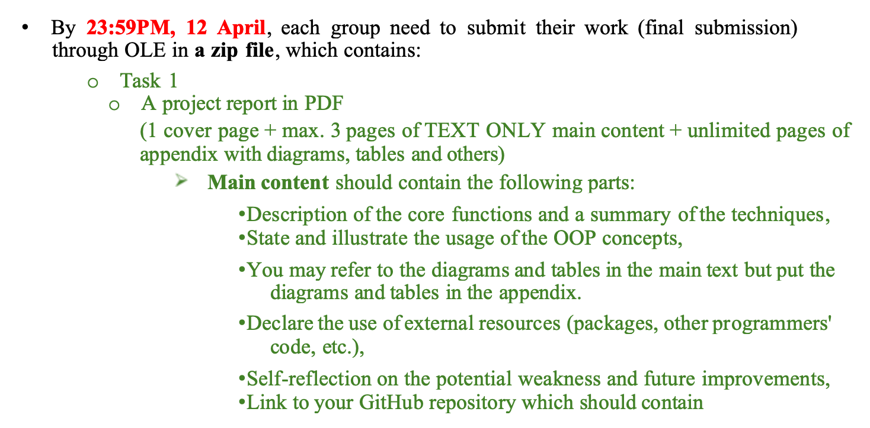
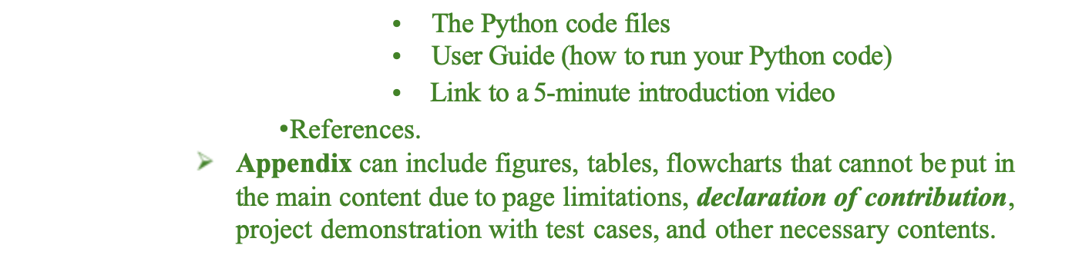

- 立即创建公开或私有GitHub仓库（建议公开，便于讲师查看）。
- 建立两个文件夹：Task1_OOP_App 和 Task2_SelfStudy。

- 参考官方示例仓库：https://github.com/XPixelGroup/HYPIR

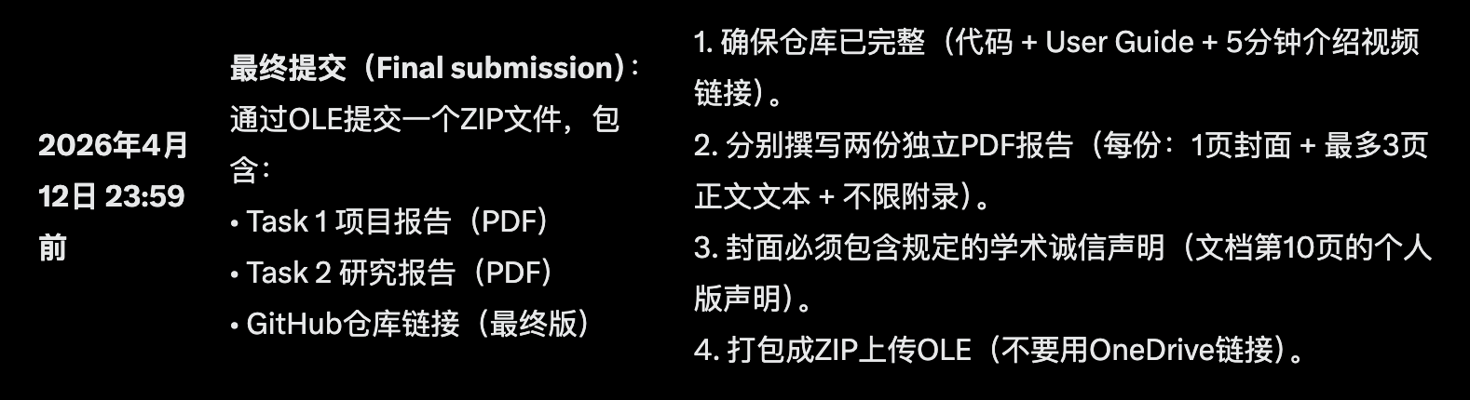

OOP-based application development
This project focuses on real-life problem solving with the concept of Object-Oriented Programming (OOP). You have great freedom to choose your topics, but we have some requirements for your project:

The implementation of your work must reflect the concept of OOP. You are required to use ALL OOP concepts introduced in the course.

You should aim for an application or a system which can be used in real-life scenarios to solve real problems, such as an inventory system, a library management system, calendar and flight scheduling system, etc. A decent graphical user interface (GUI) may slightly increase your score, but it is not mandatory for you to have a GUI for your project, as you can present the interface with Python print() function.

1) A project report in PDF
(max. 3 pages of TEXT ONLY main content + unlimited pages of appendix with diagrams, tables and others)
➢ Main content should contain the following parts:
•Description of the core functions and a summary of the techniques,
•State and illustrate the usage of the OOP concepts,
•You may refer to the diagrams and tables in the main text but put the diagrams and tables in the appendix.
•Declare the use of external resources(packages, other programmers' code, etc.),
•Self-reflection on the potential weakness and future improvements,
2) The Python code files
3) User Guide (how to run your Python code) - Github README
4) 5-minute introduction video script.

